MCCBOA  MARCH 2015 WORKSHOP  March 5-6, 2015  Location: The James B. Henry Center  for Executive Development  Michigan State University  3535 Forest Road  Lansing, MI 48910-3831  Phone: (517) 353-4350  Phone: (800) 356-5705  msuhenrycenter@bus.msu.edu  Thursday, March 5, 2015  9:00-9:30 Registration and Continental  Breakfast  9:30-9:45 Welcome & Introductions  Cheryl Sullivan,  MCCBOA President  9:45-10:30 Personal Property Tax Reform &  Other Pertinent Matters  Howard Heideman  Michigan Department of Treasury  10:30–10:45 Break  10:45-11:45 Digital Disbursements  Joseph Kiss  Bank of America Merrill Lynch  Noon – 1:00 Lunch  1:10- 1:55 Credit Card Processing with a  Twist  Patrick Albright, CEO, Noble  Larry Sachs, VP of Security  Katalin Reimonn, VP Sales  Compliant Processing  1:55-2:00 Short Break  MCCBOA OFFICERS  2014-2015  President  Cheryl Sullivan  Northwestern Michigan College  Vice President  Todd Hurley  Grand Rapids Community College  Treasurer  Lillian Frick  Mid Michigan Community College  Secretary  Larry Gawthrop  Mott Community College  Past President  Rick Scott  Kellogg Community College  Planning Meeting:  Lillian Frick, Larry Gawthrop, Todd Hurley,  Rick Scott, Cheryl Sullivan |  | 2:00-3:00 Gainful Employment Regulations  LaKeisha Marsh  Miller Canfield  3:00-3:15 Break  3:15-4:00 Hot Topics in Public Finance  Benjamin McGuire  Edward Jones  4:00-4:30 MCCA Update  Mike Hansen & Erin Schor  MCCA  4:30-6:00 Attitude Adjustment  6:00 Dinner on your own or  Group Dinner at  Harper’s Brew Pub  Friday, March 6, 2015  8:00–8:30 Hot Breakfast  8:30 – 9:30 Withholding & Reporting on  Payments to Non-US Vendors  Victoria Mundinger, Tax Sr. Associate  Rehmann  9:30-9:40 Short Break  UPCOMING WORKSHOPS  Spring, 2015  The James B. Henry Center for Executive Development  Michigan State University  http://www.bus.msu.edu/edc/  East Lansing, MI  March 5 - 6, 2015  Summer, 2015  Hagerty Conference Center  Great Lakes Campus  Northwestern Michigan College  Traverse City, MI  July 29 - 31, 2015  Fall, 2015  Amway Grand Hotel & Conference Center  Grand Rapids, MI  November 5 - 6, 2015  MCCBOA Thanks our Sponsors!!!  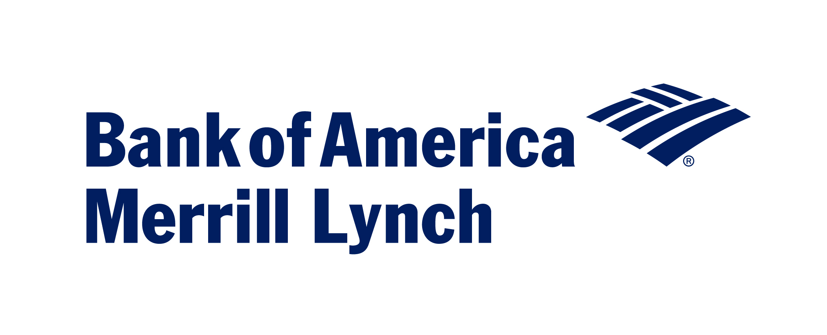 |  | 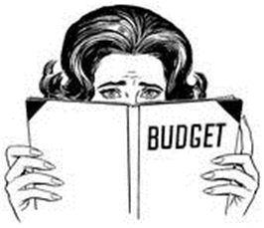  9:40-10:40 MPSERS Update  Steve Crippen & Angela  Schrauben  Office of Retirement Services  10:40-10:45 Short Break  10:45-11:30 Legislative Update  Bill Bowerman & Marilyn  Peterson  Senate & House Fiscal  Agencies  11:30-11:45 Bull Session  Moderator: Todd Hurley  - Survey Results  - Millage Updates  - NACUBO  - CCBO  - MCCBOA Website/Listserv  - Ideas for Best Practice - Other  11:45–12:00 Association Business  - Approval of minutes  Fall 2014  - Treasurer’s Report  - Adjournment  Michigan Community College Business Officers Association  Spring Workshop  March 5-6, 2015  Meeting Location:  The James B. Henry Center for Executive Development  Michigan State University  3535 Forest Road  Lansing, MI 48910-3831  Lodging at:  Candlewood Suites  3545 Forest Road  Lansing, MI 48910  (517) 351-8181

